# Week 3: 3D Modeling - Multi-Part Part Studio

|  |  |
| --- | --- |
| **Concepts** | * Using Boolean operations * Applying linear and circular patterning * An introduction to concurrent top-down and bottom-up designs * Creating a Multi-Part design in a Part Studio |
| **Models** | * Tray - used for linear patterning * Nozzle - used for circular patterning * BU35 Cantilever Clamp |
|  | |

# 

# 

# Before we get started…

# Last week, we learned about fillets and chamfers, which were examples of “Feature Based Modeling” that can manipulate existing 3D geometry without a 2D sketch. This week, we will learn about booleans, which also manipulate 3D parts, and patterning, which manipulate parts, faces, and features. Then we will use some of these tools and others we’ve learned previously in creating our first big project – a Cantilever Clamp. The Cantilever Clamp will all be built in a single Part Studio using a Multi-Part modeling approach.

# Boolean Operations

**Boolean Operations** are a fundamental part of CAD, and in fact, you may remember that they are actually a mathematical function from way back in algebra class! There are four types of Boolean operations in Onshape: New, Union, Subtract, and Intersect. New is used to create new parts, and the other three are used to operate on existing parts. Below is a graphical representation of how they work. More information on Booleans can be found in the help [here](https://cad.onshape.com/help/index.htm#booleanparts.htm), and remember, **booleans only work when parts interfere with each other** (or are just touching).

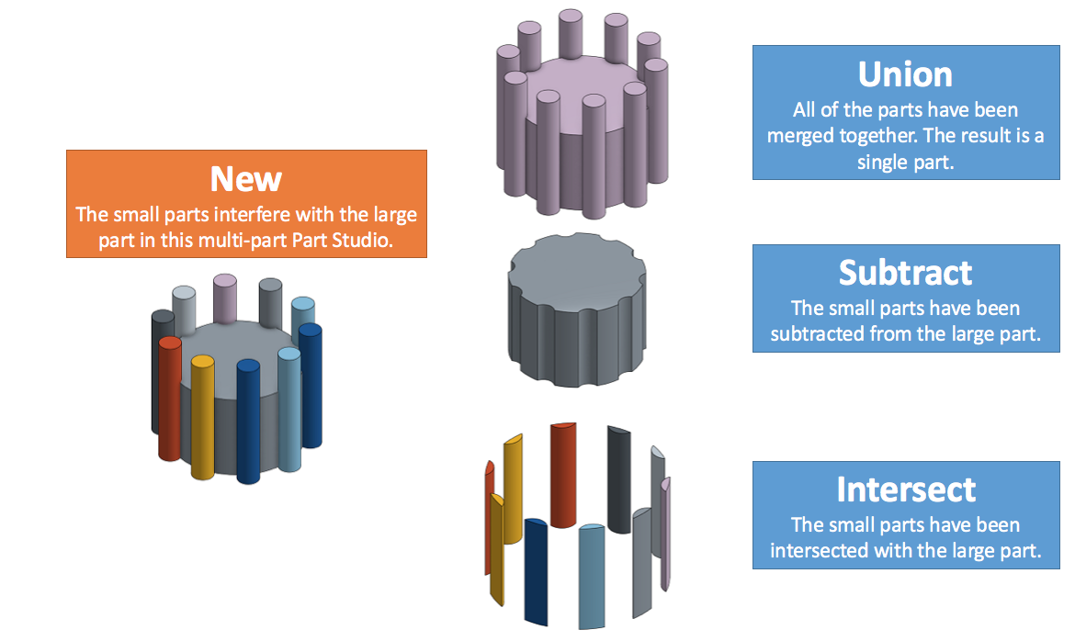

To use the Boolean Operations, click the Boolean Tool . A dialog box will show up and you can choose among three operations:

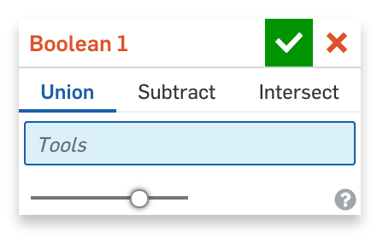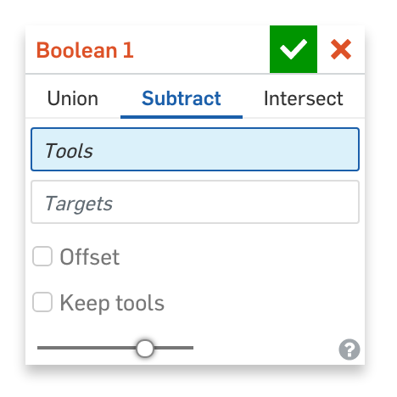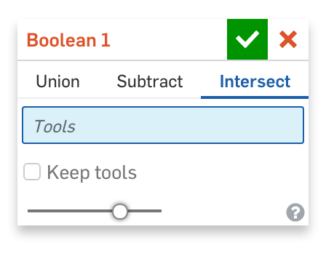

Notice that there are **Union**, **Subtract**, and **Intersect** tabs on the top. Each Boolean Operation has a “Tools” field, but only Subtract has a “Targets” field since Subtract removes a tool part from a target. So in the Subtract example above, the tool parts were the small cylinders, while the target was the the large cylinder.

Also notice the “Keep tools” option. If the “Keep tools” option was selected in the example above, the tools in the Subtract example (i.e. small cylinders) would appear, as well as the tools in the Intersect example (i.e. both the big and small cylinders).

## In-Class Exercise #1:

Open up the public document called “College - Boolean Operations” and make a private copy. Perform the three Boolean Operations (Union, Subtract, Intersect) on the parts in the corresponding Part Studios to create the three models in the first example.

# Patterning

Much like mirroring (which we learned in week 2), patterning is a way to automatically build identical geometry in CAD. In addition, in Onshape it can be “bundled” with boolean operations such as subtract and intersect, and the result is a versatile and powerful tool.

In a Part Studio in Onshape, both 2D and 3D geometry can be patterned, and the patterns can be either be linear or circular. Here are the links to the [linear sketch pattern](https://cad.onshape.com/help/#sketch-tools-sketch-pattern.htm), [circular sketch pattern](https://cad.onshape.com/help/#sketch-tools-circularsketch-pattern.htm), [linear pattern](https://cad.onshape.com/help/#linearpattern.htm), and [circular pattern](https://cad.onshape.com/help/#circularpattern.htm) sections in the Onshape Help.

## Linear Part Pattern

Let’s use a Linear Feature Pattern to create the following assembly fixture. Instead of individually making nine of the same 3D features, we can actually just create one, and pattern that across and down the block three times each:

## 

1. Open the public document “College - Linear Part Pattern” and make a private copy of it. It should look like this:

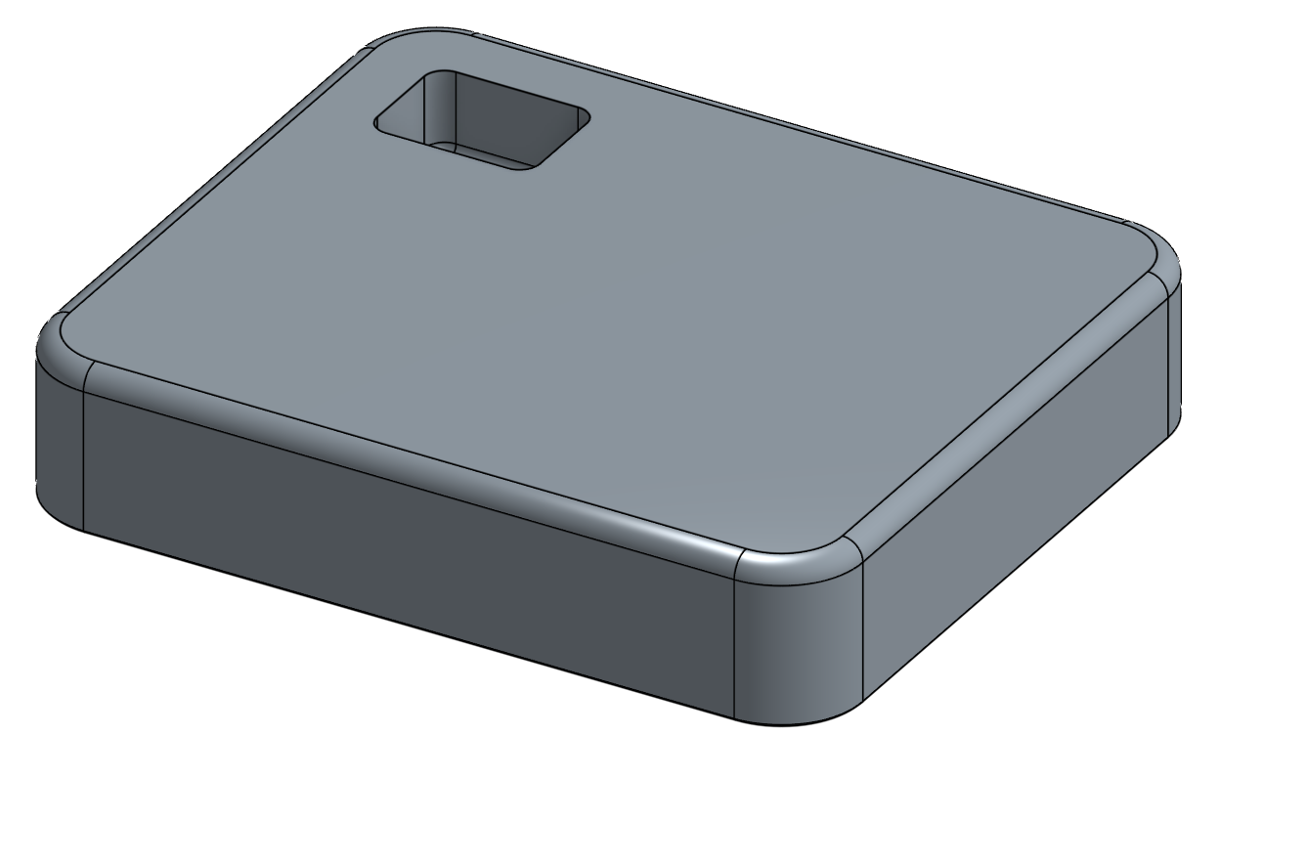

1. Let’s add a nice lead-in chamfer, to make the parts easy to drop in place. Create a chamfer that is .06” wide, and .12” deep, using the “Two Distances” Chamfer Type:

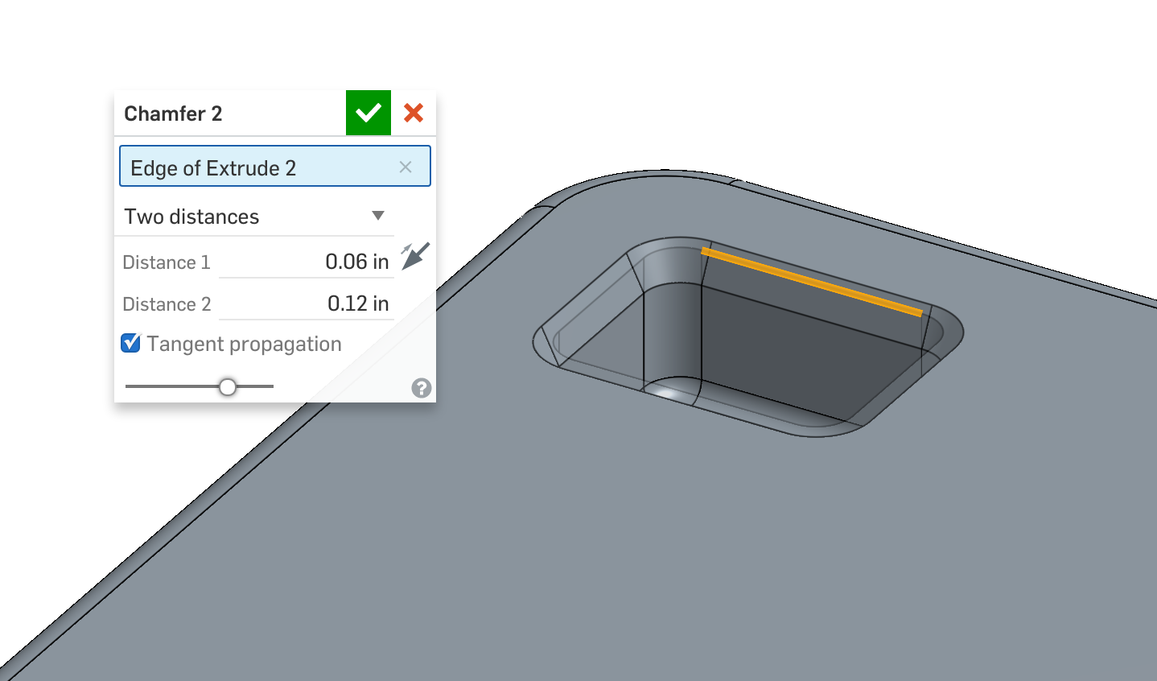

1. We’ll pattern the pocket in two directions: First, let’s pattern it across, by referencing the top edge of the part (highlighted in orange). We’ll pattern 3 instances with a 1.5” pitch. Make sure that “Pocket Extrude,” “Pocket Corner Fillet,” “Pocket Base Fillet,” and the chamfer you created in the previous step are selected. Also make sure that the arrows  are pointed in the right direction (boxed in blue below):

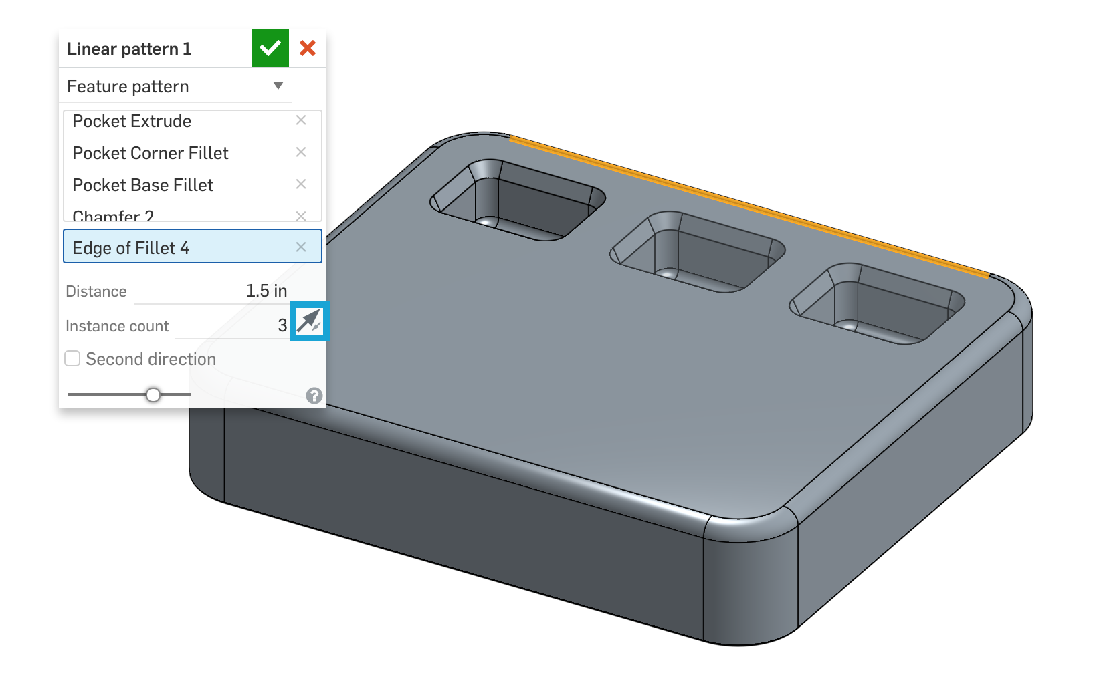

1. Now, in the same feature toggle the “second direction” toggle. This will allow us to reference the left edge of our part, and pattern 3 more instances at a 1.25” pitch:

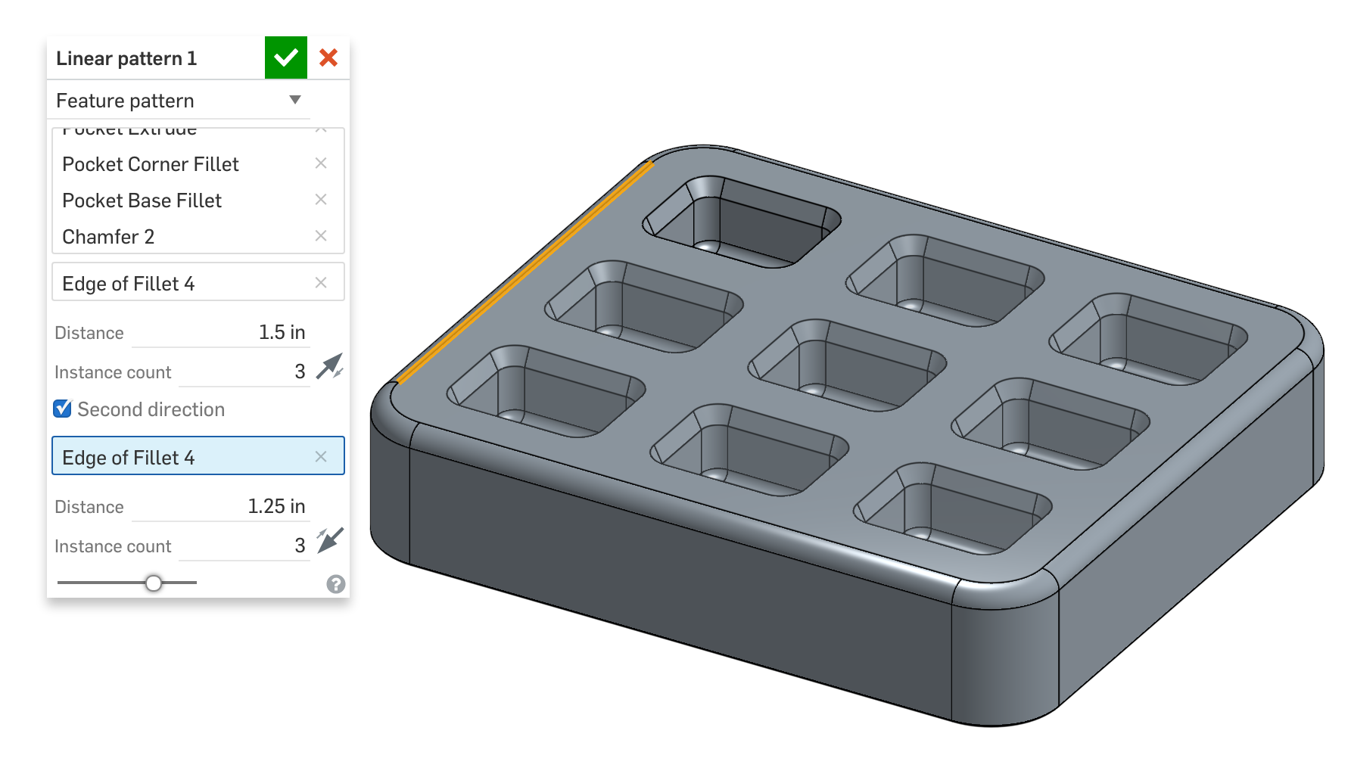

1. Your part is finished!

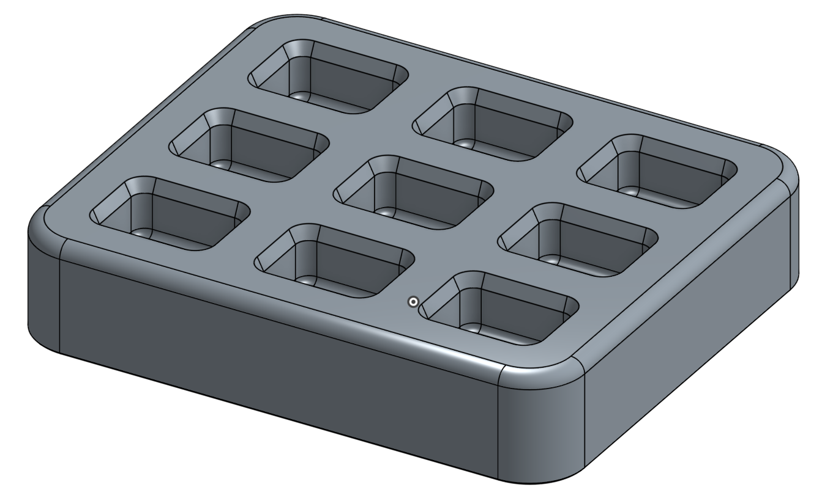

*Pro Tip: Just as before, pay attention to our control of the fillets and chamfers. We have conveniently chamfered and filleted the edges of the pocket prior to the pattern, so we can include them in the pattern feature. Not only does this save us time, but it also prevents a possible typo or misclick while doing unnecessary repetitive tasks (things best left for computers, not humans). In addition, we’ve kept our “cosmetic” rounds and break edges until the very end of our model. Good job!*

### In-Class Exercise #2: Top-Down Linear Part Patterning

1. For this exercise we are going to create the same Assembly Fixture, but from a “Top-Down” approach. Go to Part Studio 2. It should look like this:

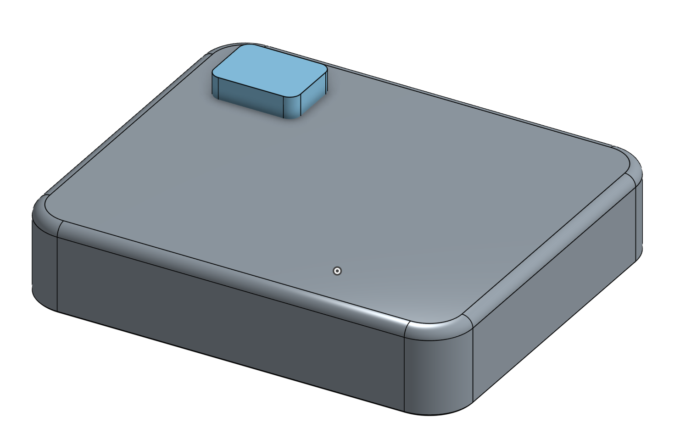

1. If you hide Part 1, you can see that Part 2 is filleted on the bottom:

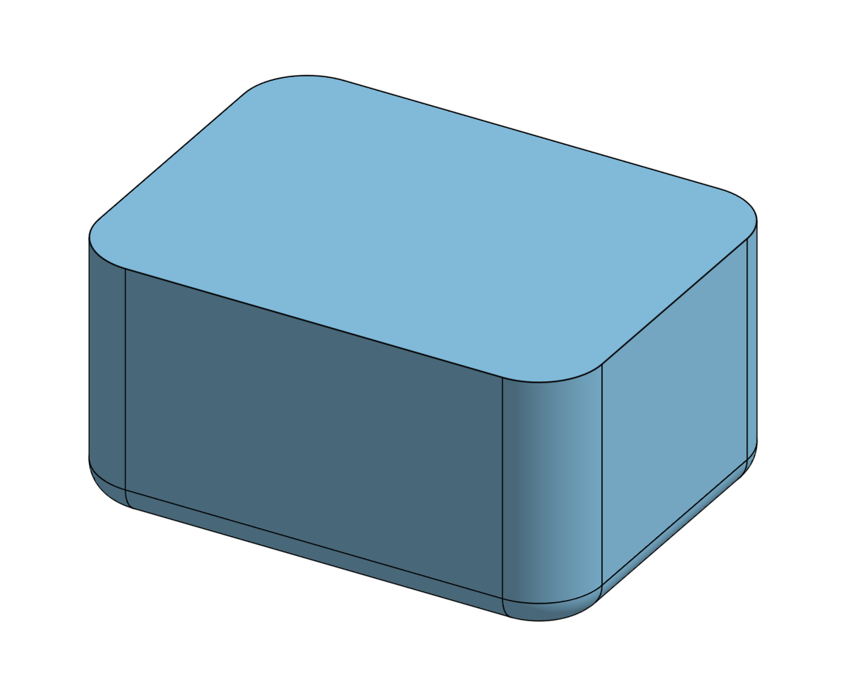

1. Now, pattern the part like you did in the previous example and boolean subtract the part from the fixture to create the pocket.
2. Can you figure out how to include the boolean subtract with the linear pattern?
3. Right now the pocket is the exact same size as the part that it goes in it. How could we easily add a .020” gap around the part in the pocket to account for manufacturing tolerances?

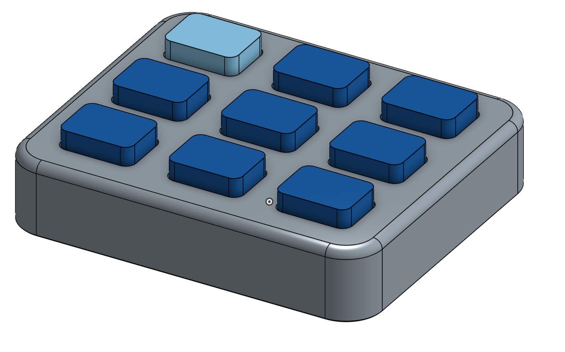

## Circular Part Pattern

This is probably the more often used pattern tool. If you think about it, there are many circular patterns that we see on a daily basis such as wheel spokes, fan blades, shower head jets, etc. For this exercise, we will create this flanged nozzle:

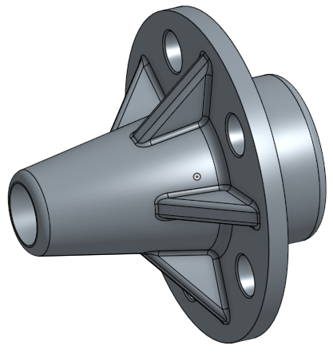

1. Open the public document “College - Circular Part Pattern” and make a private copy of it. It should look like this:

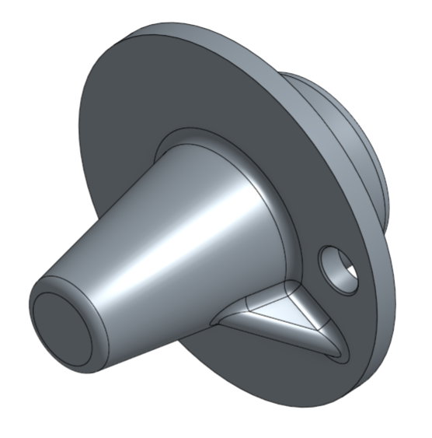

Note that there is a sketch named “Hole Sketch” for the circular hole and a sketch named “Triangular Rib Sketch” for the triangular rib already made for you. The hole is chamfered (“Chamfer 1”) and the triangular rib is filleted (“Fillet 1”).

1. We’re going to create a circular pattern of this hole (and chamfer) around the centerline of our revolve feature. Make sure that “Main Body Sketch” is unhidden so you can see the dotted centerline.
2. Click on the Circular pattern tool  and make sure that ”Feature pattern” is selected from the dropdown menu. This is because we’re going to pattern an extrusion, not a part. Select “Hole Extrusion” and “Chamfer 1” for “Features to pattern” and the centerline for “Axis of pattern”. For this feature, we will create five equally spaced holes:

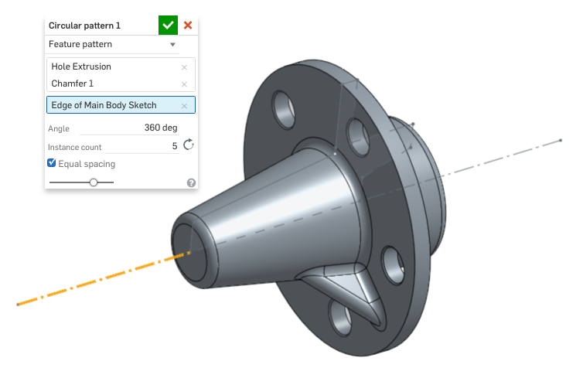

1. Now, let’s make a circular pattern of the triangular rib. This time, select “Triangular Rib Extrusion” and “Fillet 1” for “Features to pattern”:

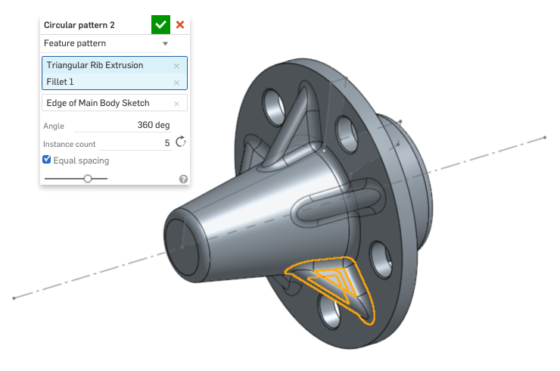

*Pro Tip: You can also make the circular pattern by picking the conical or cylindrical faces of the model instead of the sketch axis. This can save you a lot of time!*

1. Let’s finish off by extruding out one of the existing circular edges:

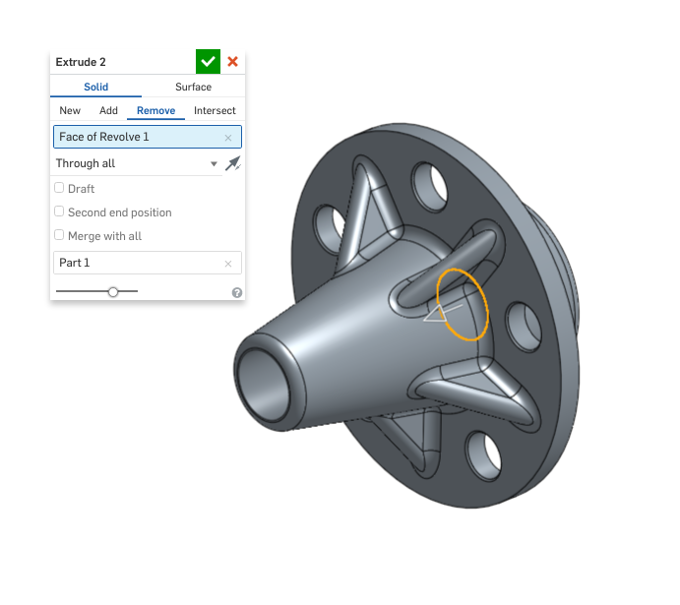

1. Your model is complete!

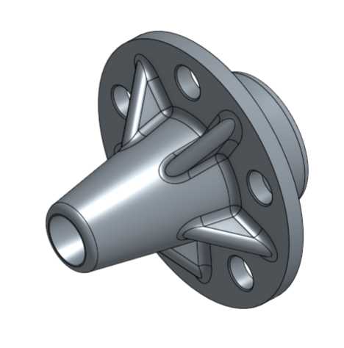

## Sketch Patterning

In addition to patterning features and faces, sketch entities may be patterned as well. Unlike the previous functions we’ve learned in this week’s lesson, sketch patterning, as the name implies, only manipulates a 2D sketch. This functionality is accessible from the sketch toolbar as shown below.

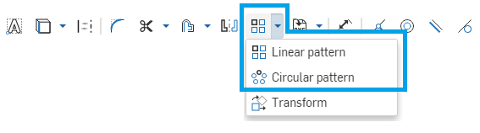

This can be very helpful, when you want to pattern construction geometry, or when the sketch is complex. It won’t be covered in this curriculum, as the functionality is almost identical to the feature and face pattern exercises above. For more information on sketch patterns, refer to the Onshape Help here:

* Linear sketch patterns: <https://cad.onshape.com/help/#sketch-tools-sketch-pattern.htm>
* Circular sketch patterns: <https://cad.onshape.com/help/#sketch-tools-circularsketch-pattern.htm>.

# Assemblies in Onshape

Now that we’ve learned about different ways to manipulate 2D and 3D geometry, let’s switch gears and learn about assemblies. An assembly in the real world is something made up of many parts. For example, you may *assemble* an IKEA desk, using parts you bought in a kit from IKEA.

Assemblies in CAD are similar, but have a very distinct meaning, even more so in Onshape. Just like in the real world, CAD Assemblies are where you bring different parts together and *assemble* them to make a final product or a *subassembly* to an even bigger product.

As we’ve seen already, Onshape actually lets you make multiple parts in a single Part Studio, which sounds an awful lot like an “assembly,” so what’s the difference between an Onshape Part Studio and an Onshape Assembly and when do you use which?

**Part Studios:** Part Studios are where you create and modify geometry. Unlike other CAD systems, you may make as many parts in a single Part Studio as you want. This technique is called *Multi-Part Modeling* and it’s very powerful because, as we’ve seen, you can make parts that highly depend on one another.

In Onshape, Multi-Part Modeling allows the designer to create a single sketch which can create multiple parts (as we’ve already done), and a single feature can affect multiple parts at the same time. This is different from traditional CAD applications.

**Assemblies:** Assemblies are where you take the parts that you’ve already made and put them together to make something bigger. You use things called *Mates* (which we’ll learn all about in Week 4) to position the parts where you want and to define *movement*. In other words, assemblies are where you assemble parts and view how they move. We’ll talk more about this later, but assemblies are also where you would *instance* a part (use the same part multiple times). Lastly, assemblies often experience faster performance of big, complex assemblies as compared to having a single Part Studio with the same number of parts.

Now, this may be a lot to take in, but it’s important and exciting! We’re about to go from making simple little parts to making fully-working multi-part assemblies that move. But, before we do, there’s one more important concept to cover and it’s the distinction between two different and common styles of designing:

1. **Bottom-Up Design** is when a product is designed by creating sketches, then features, then parts (often one per Part Studio), and then assemblies. In this approach, the geometry is created starting with the lower level entities (like 2D lines and circles) up the hierarchy to the highest level assembly (such as the final product being built).
2. **Top-Down Design** is when the shape of an overall product is sketched first, and then different regions of that sketch are used to create the lower level parts and their features. Top-Down is a more intuitive way to approach a design because typically we, as designers, envision the final product first, then as time goes on, we refine the concept into finer and finer detail.

Onshape has the unique ability to allow a design to be created in Top-Down and Bottom-Up concurrently. This may not make sense right now, but we will come back to this subject after the next few lessons, and tie the concepts together. *Hint: Multi-part Part Studios let you design all the parts of a final product within the same environment.*

# Top-Down Design with Multi-Part Design

We are going to build this Cantilever Clamp, and since we already know what the clamp is going to look like, we are going to approach it with a Top-Down strategy, and start with a sketch of the overall shape:

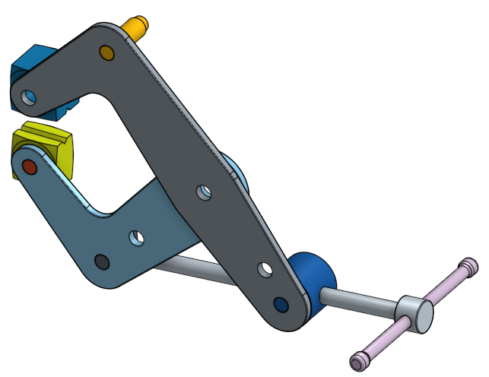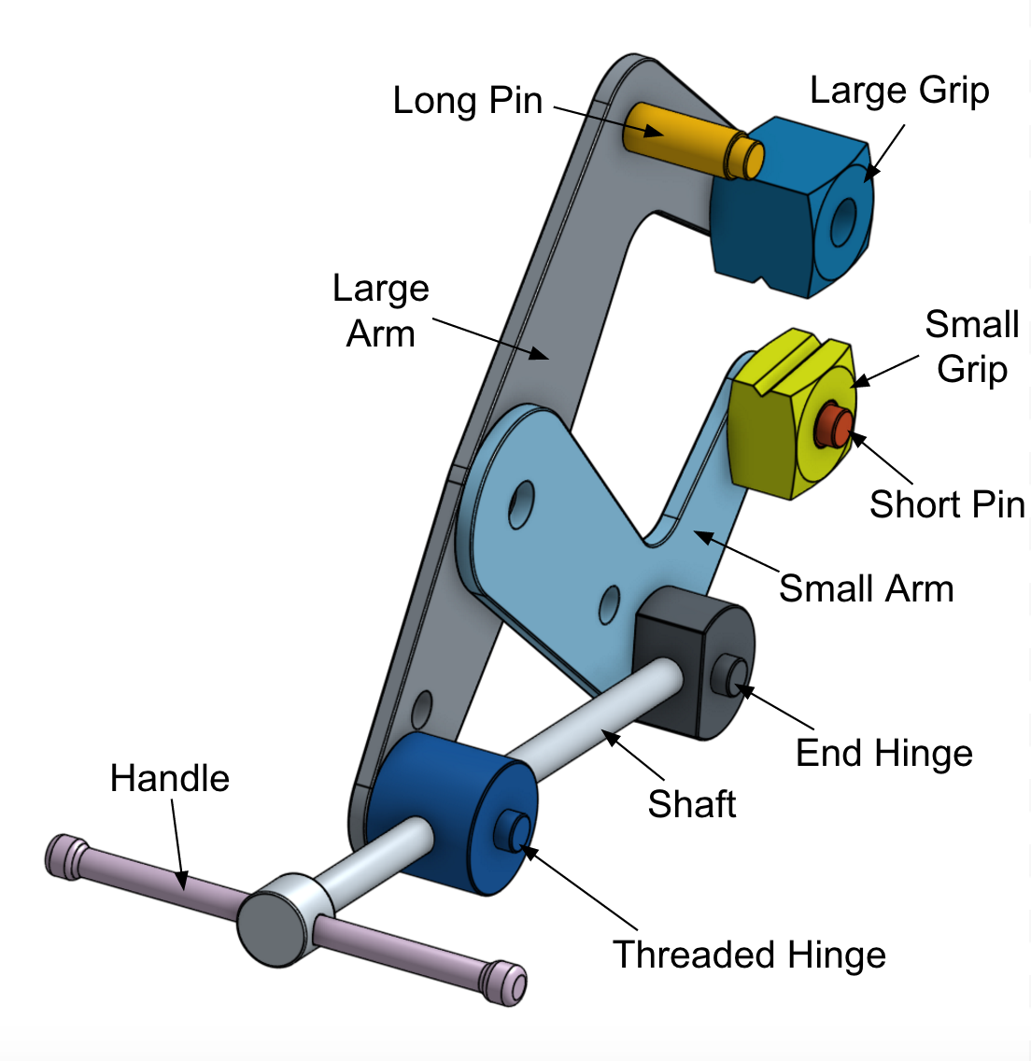

Let’s look at some of the vocabulary associated with the design. The clamp has two L-shaped **arms**, which serve as the main frames of the design. The clamp also has two **pins**, which connect and fit to the arms, and **grips**, which are used to grasp/clamp objects. Two **hinges** hold the rod, also known as the **shaft**, in place. We can imagine that the user will hold onto both sides of the **handle** to use the clamp.

So what is its design intent? What are some things you notice about the design? You might notice that quite a few parts in this multi-part design, such as the pins, grips, hinges, and handle, are symmetrical. You might also notice that the arms are stacked on top of one another, so you might note that they share a plane, suggesting that the arms were made from multiple sketch regions (which we learned about last week).

Now that we have an idea on the design intent of the Cantilever Clamp, let’s begin sketching!

1. Start by creating a new document and creating the following sketch on the front plane (Note how the sketch is fully defined. Where there are no dimensions, there must be constraints to describe the design intent):

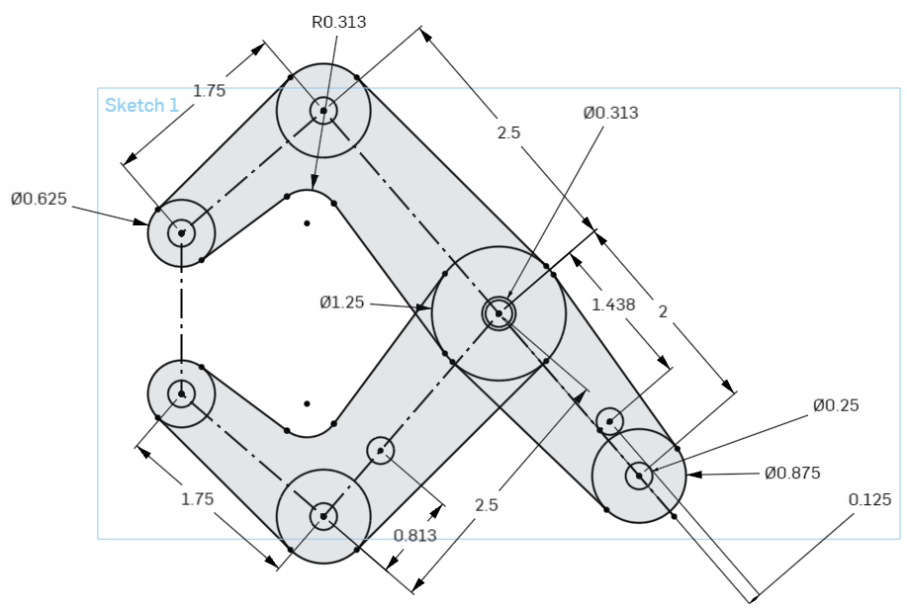

*Pro Tip: This is a complex sketch. To tackle it, break it up into pieces in your head. Start with the overall shape (such as the joints and the construction lines), and add in those dimensions and constraints. Once that is fully constrained, then add in the outer profile, and then finally all of the tangent constraints. Leaving the tangent constraints until last is a best practice, just don’t forget them!*

*For a little more help, here is a screenshot of just the joints and construction lines for the Large Arm (Large one at the origin):*

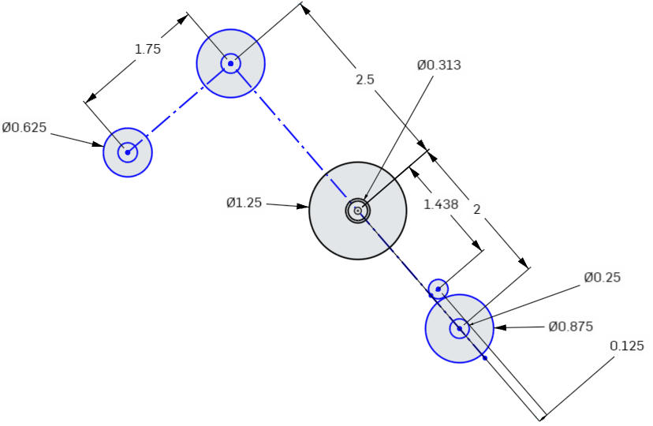

*Note that the length between the origin and the point where the small circle touches the dotted line (not the center of small circle) is 1.438”.*

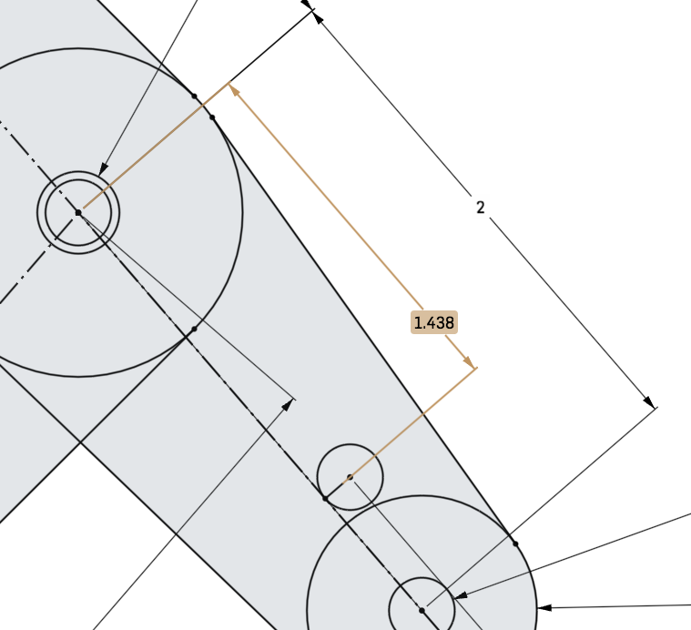

*And here is the layout for the Small Arm (again, showing the large circle at the origin):*

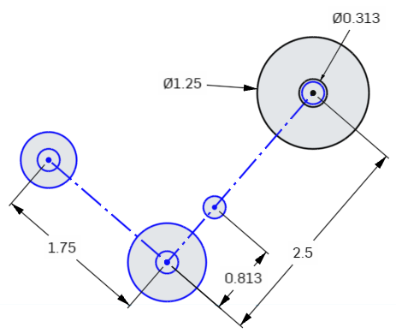

*Here are the full sketches for the “large arm” and the “short arm” with their constraints. Try it on your own first, then use the pictures below for reference (as with most things in CAD, there are many ways to do the same thing, so your sketch may not look exactly like this). Keep in mind, that both arms should be in a single sketch:*

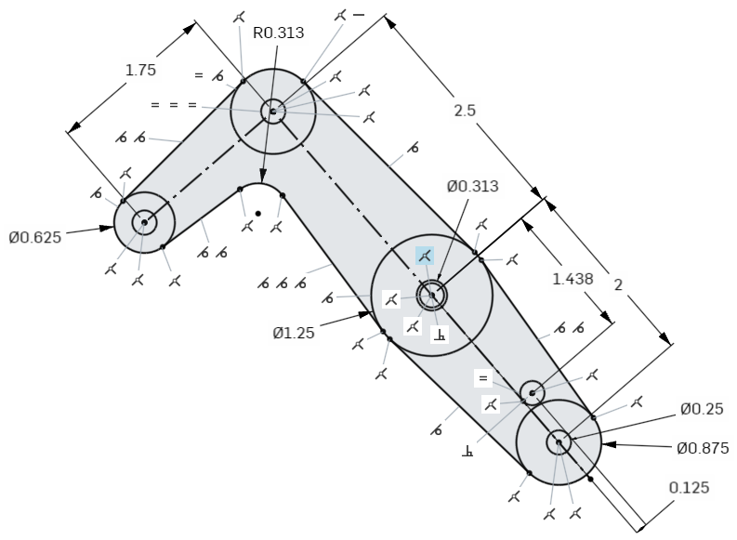

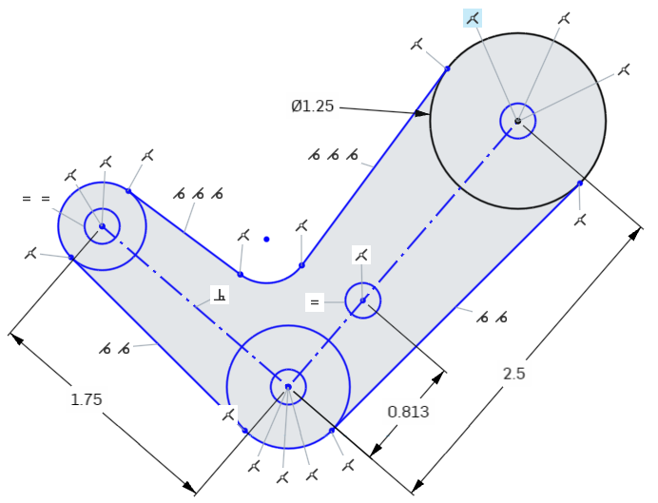

*Here are some hints regarding the sketch entities that don’t have dimensions. In each picture below, the highlighted circles have the same radius:*

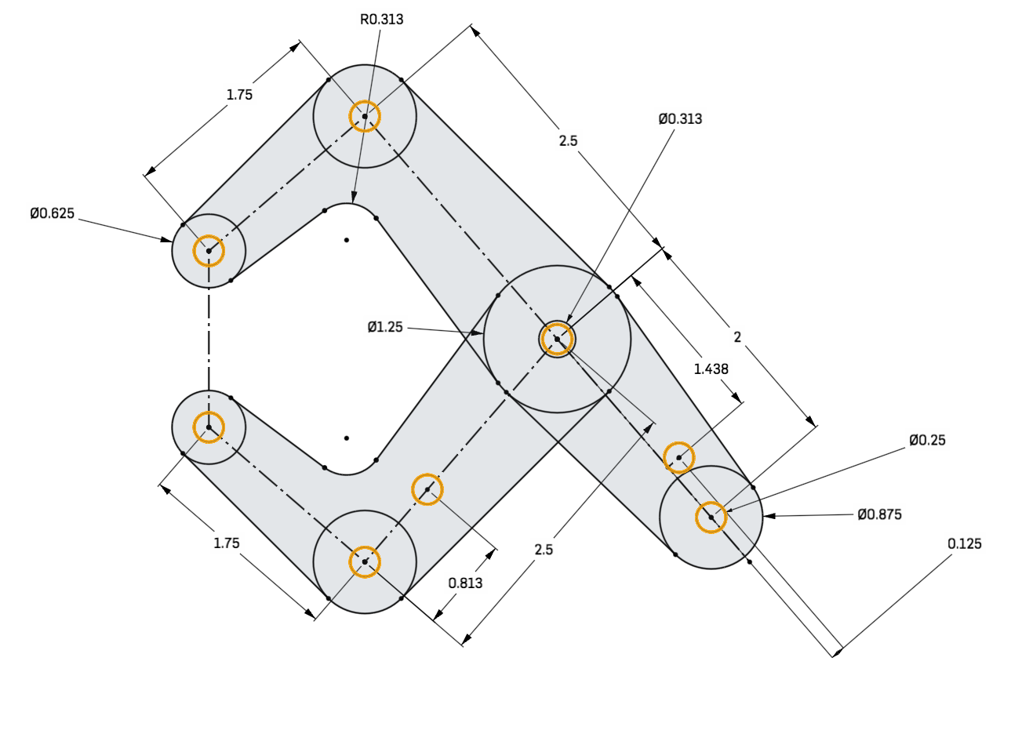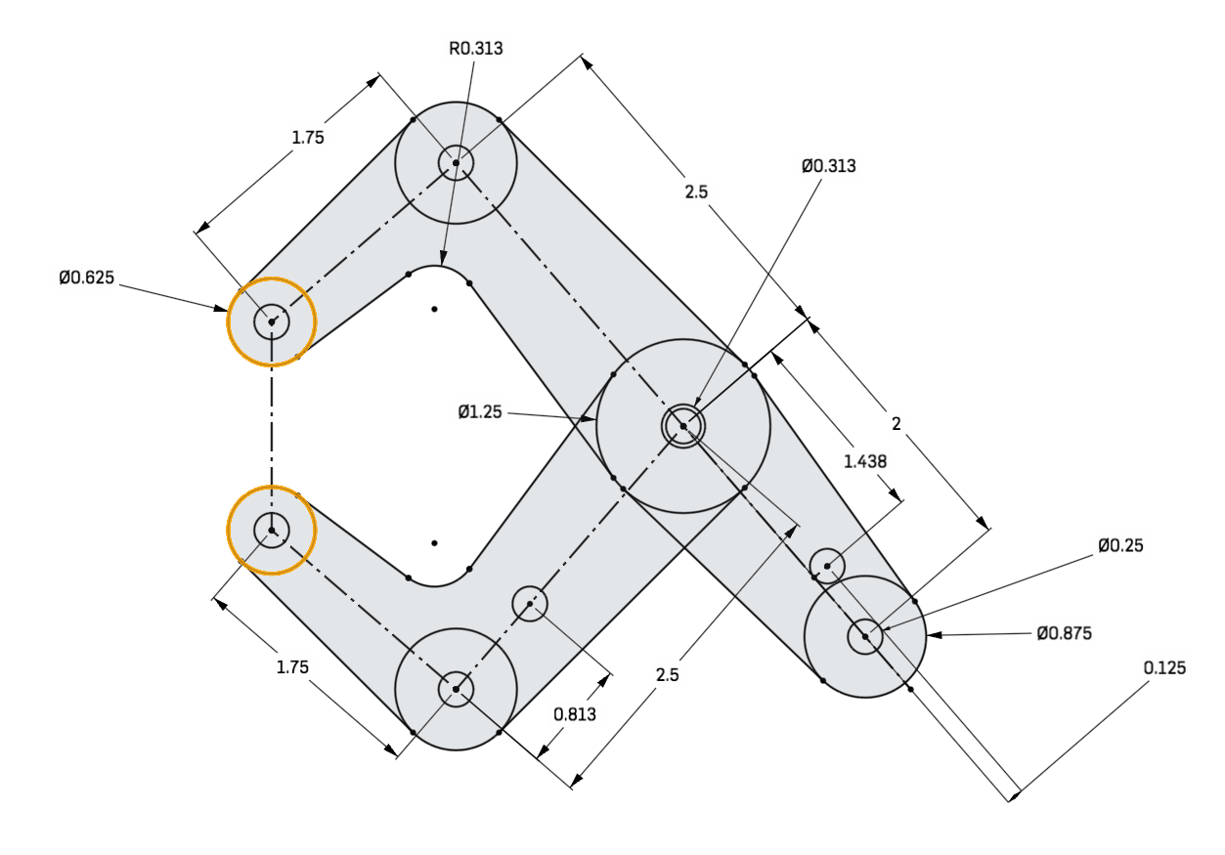

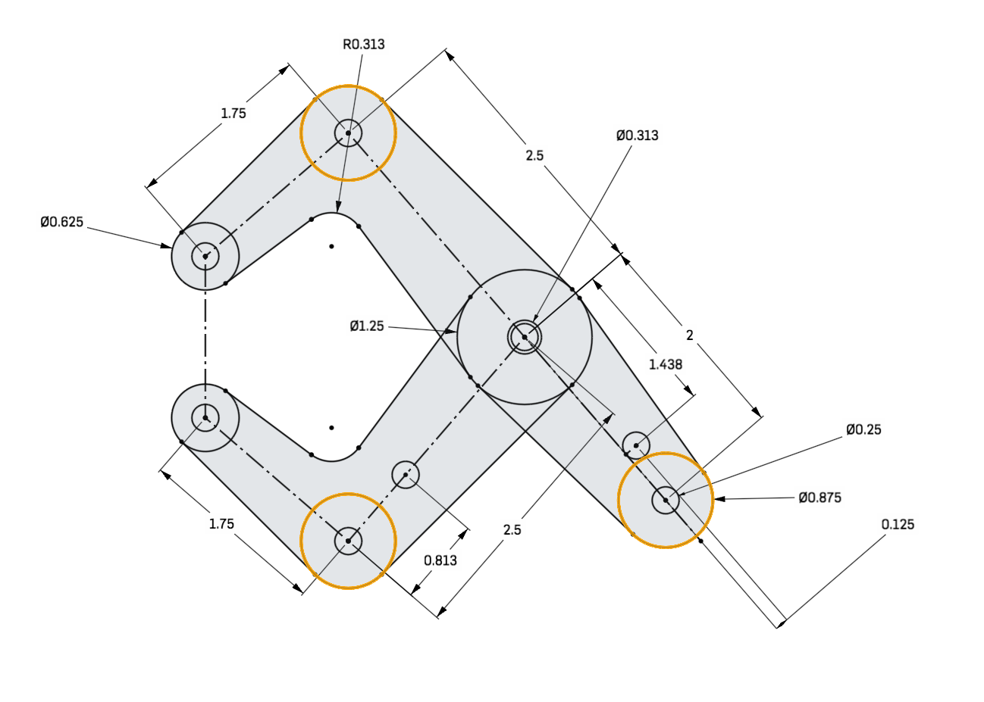

*The two arcs have the same radius as well.*

*All the highlighted lines are tangent to the highlighted arcs/circles they are touching:*

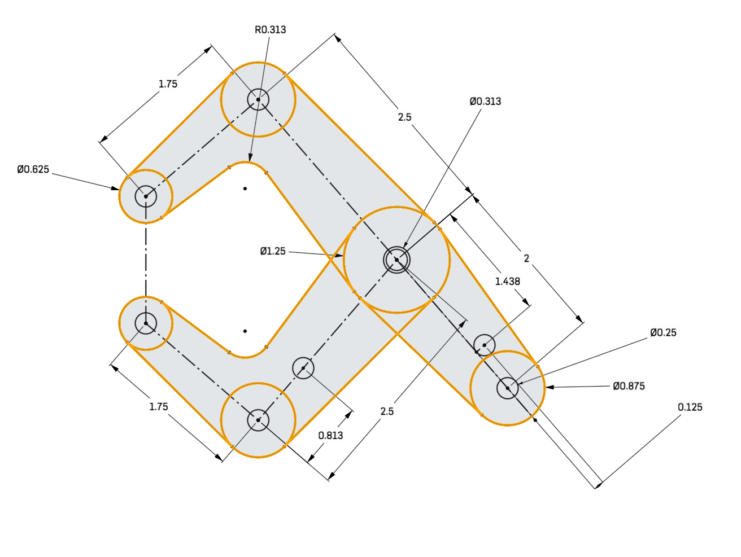

*Even these lines are tangent to the nearest highlighted circles:*

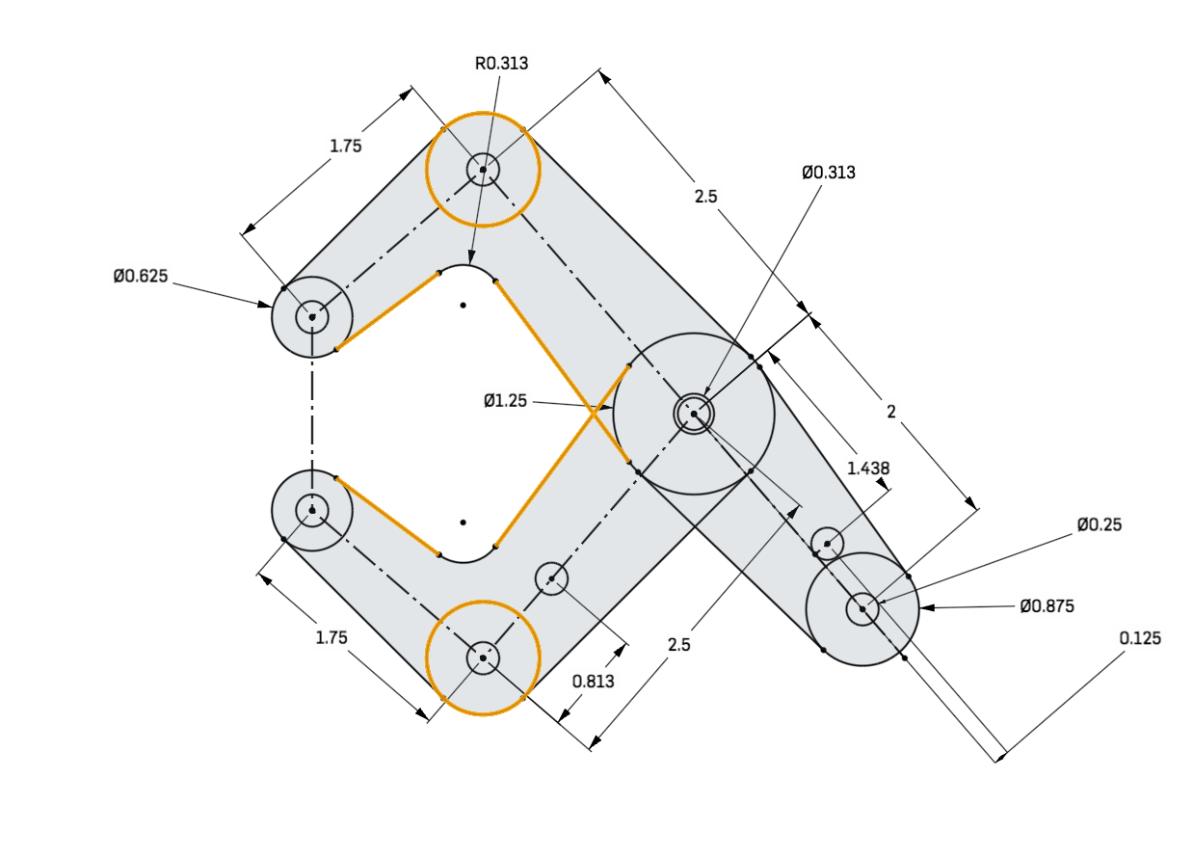

1. Once your sketch is black, extrude the large arm of the clamp .125” thick towards the screen by selecting the necessary sketch regions.

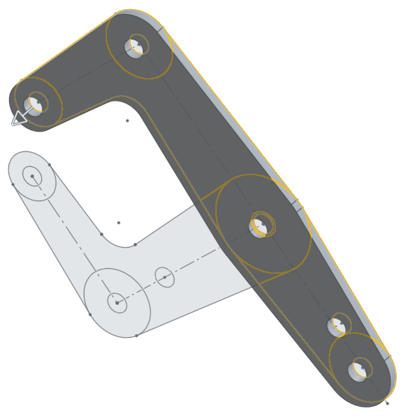

*Pro Tip: One way to check your work, is to see if the volume of the part is correct. In our case, the volume of the large arm should be 0.788 in3. To check this, select the Part in the parts list. When you do this, a small icon will pop up in the lower-right hand corner of the graphics screen (**). Clicking on that will show the Mass Properties screen:*

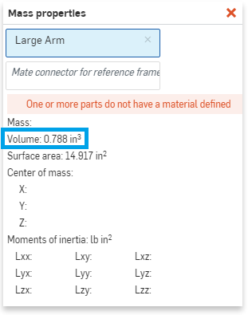

1. Now, extrude the smaller arm .125” away from the screen. In addition, select the “New” option in the extrude dialog box, and accept it:

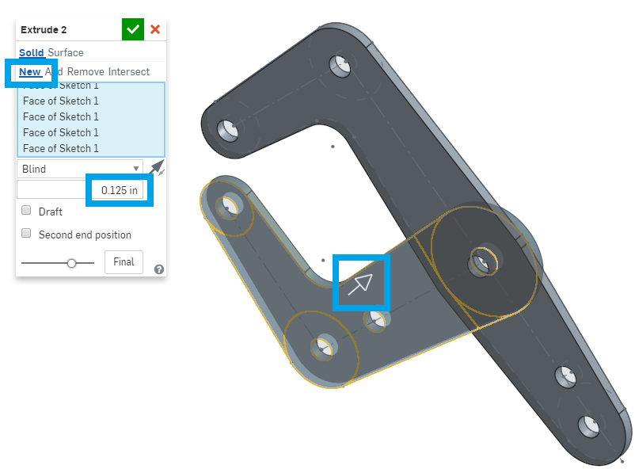

1. You should notice a few new things: First, the new extrusion is a different color, and that the parts list now shows two parts. Let’s right-click and rename these parts to “Large Arm” and “Short Arm”.

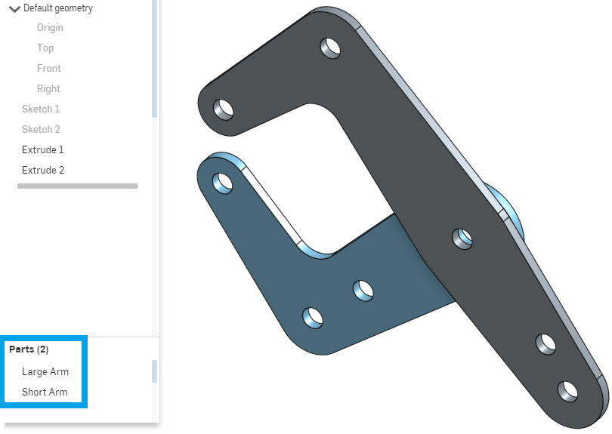

1. Next, let’s sketch a few circles, two with a diameter of 0.313” and another at 0.875”, on the front face of the Large Arm (these are for pins):

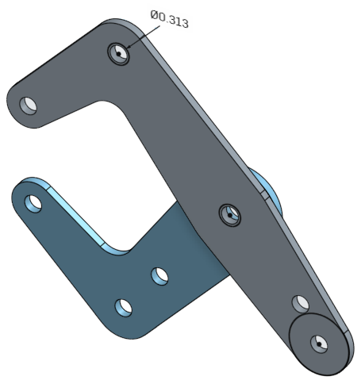

1. Next, let’s sketch a “D” shape on the front face of the Short Arm. Note that the solid line is NOT vertical, but is perpendicular to the dotted line:

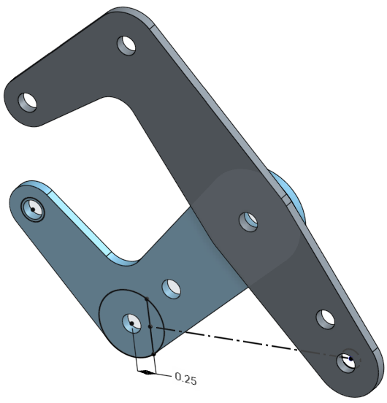

1. Next, let’s create a plane offset from the Front plane by .375”, and let’s rename this feature “Mid Plane”. Remember how we noted before that many parts in this design are symmetrical and think about how the Mid Plane might be useful in modeling this Multi-Part design. The picture below shows the “Right View” and highlights the Front Plane:

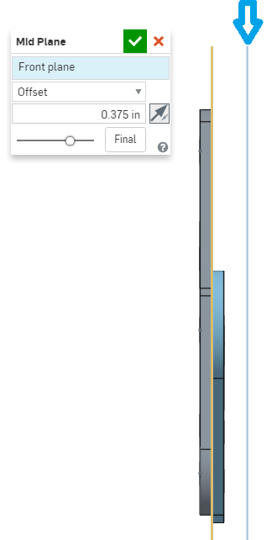

1. Now, we can extrude the pins up to our mid plane. To accomplish this, select the “Up To Plane” option from the depth pull down menu. To keep things neat and tidy, unhide/hide sketches as needed:

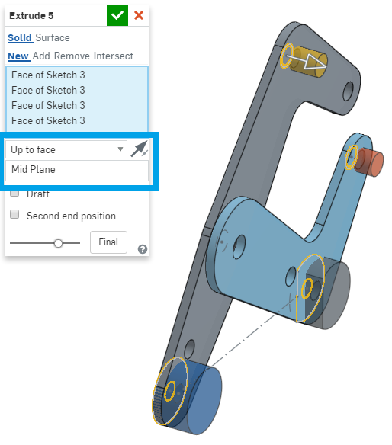

1. Let’s rename our new parts in the following manner:

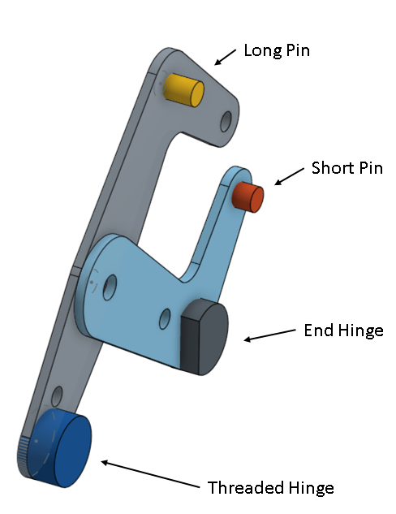

*Pro Tip: Take a break! It’s always good to take a break from work every once in awhile. In this case, sitting down for long periods of time can be detrimental to your health. Complex CAD projects can take hundreds, if not thousands of hours, and the smartest way to approach large projects is in small chunks.*

### 

## Boolean Operations

1. Next, we will perform a boolean operation on the pins. Click on the Boolean Tool . Select the “Subtract” option (in other CAD software this function is also known as a “Cut Out”, “Cavity”, “Cut”, or “Remove” Feature/Operation). The Tools will be the Large Arm and the Short Arm, and the Targets will be the two pins and the two hinges we just created in the previous step. Check off “Keep tools”.

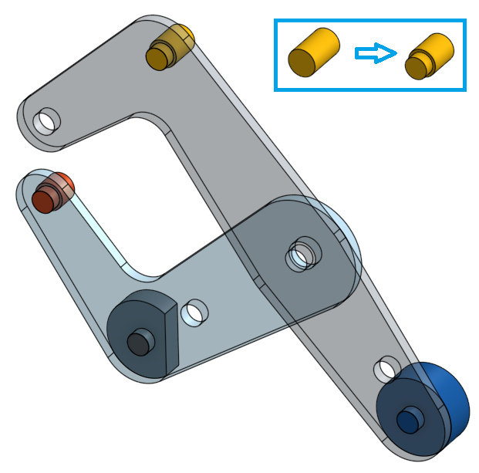

*Pro Tip: The inset in the picture above shows the details of what is going on: There was an interference between the arms and the pins. Since the hole in the arm is smaller than the pin, a “subtract” operation removes the interference, and cuts the material out of the pin (the target) thus created a step in the pin. This is a very smart way to model a “press fit” interface, because it is parametrically tied to the hole in the arm. This means, that if the hole changes, so does the diameter of the neck in the pin. Practice - Modify the size of the hole in the arm, and watch how the pin updates automatically! For tighter fits (such as a “press fit”) use the offset option to design in a small interference.*

1. Add a .010” chamfer (also called a “break edge” or “edge break”) to the following edges on the pins & hinges (don’t forget the short straight edges on the end hinge):

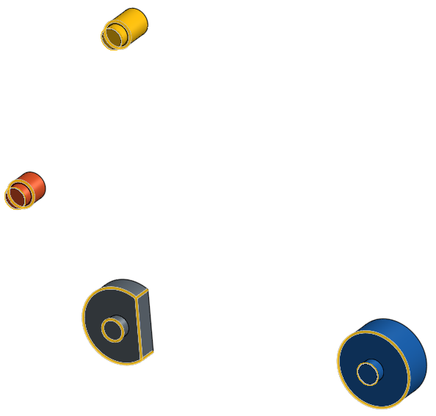

## Mirror Tool

1. Now, let’s mirror the pins over the Mid Plane. Click the Mirror Tool , and select the pin and hinge parts for “Entities to mirror” and the Mid Plane for the “Mirror plane”:

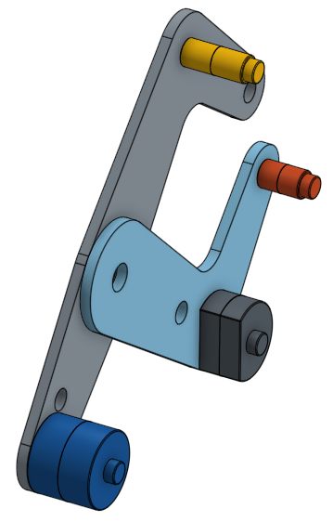

*Pro Tip: Up to this point, we’ve only really been working on a “half model”. This means, that we have been taking advantage of the symmetry of the design, and focusing on parts that reside on one side of our “Mid Plane”. This is a very effective (and time saving) approach, but you must recognize symmetry in order to use it. What’s the take away point? Engineers and Designers must be very observant and use foresight to create, intelligent, robust CAD models.*

1. Next, select all of the pins and hinges, and merge them together using a Boolean “Union” operation. The resulting geometry should look like this (note how the “creases” in the pins/hinges at the midplane are now gone):

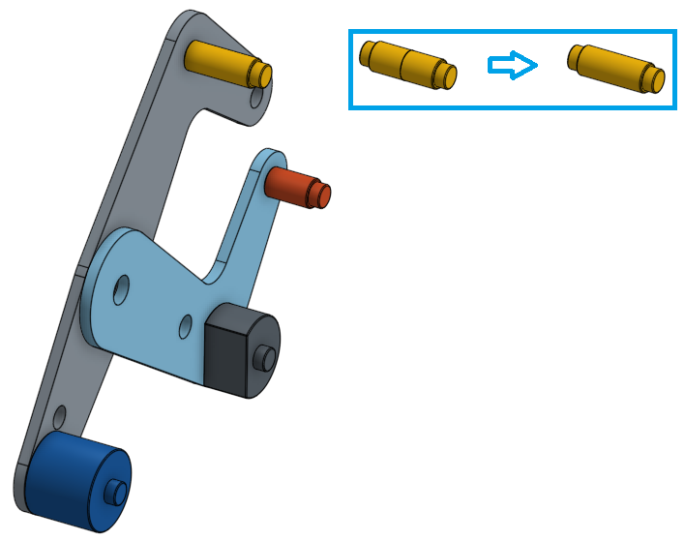

*Pro Tip: Instead of using a Boolean “Union” operation, you could have also used the “Add” function in the Mirror Tool in Step 12. If you select your original part as the “Merge scope,” Onshape will automatically “union” the original and mirrored parts together.*

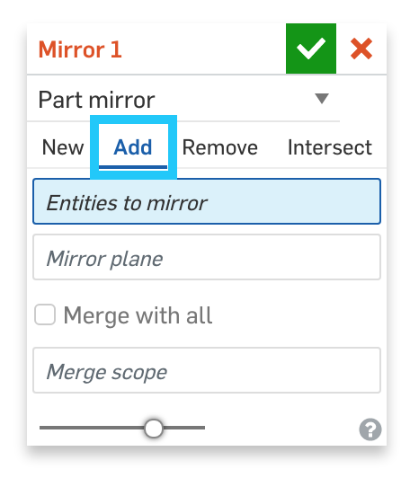

1. Next, let’s extrude a cylinder with diameter 0.25” and height 0.5” into the end hinge (Which has been made transparent for clarity). Note how construction lines are used to find the center of the sketch plane, where the center of the circle is located. Make sure the extrude is a “New” part, and rename the part in the parts list “Shaft”. Note the fully constrained sketch. How do we know it is fully constrained? How is design intent being captured in the sketch? (In other words, “how is the circle being located”?)

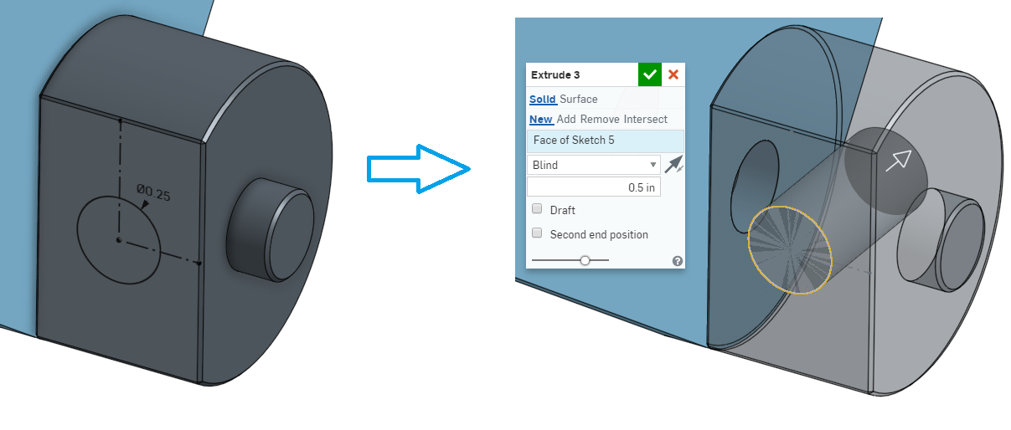

*Pro Tip: In the picture for step 14, we made the End Hinge transparent, so it is easier to see what we are trying to do. To make a part transparent, just select it (either on the graphics screen or from the Parts List), right-click, and select “Edit Appearance”. At the bottom of the menu, slide the “Opacity” slider to change the transparency level. More info here:* [*https://cad.onshape.com/help/#appearance_editor.htm*](https://cad.onshape.com/help/#appearance_editor.htm)*. Visualization and appearance tools are extremely helpful during design, as they allow us to see exactly what we want to see.*

1. Extrude the same circle AWAY from the end hinge 5” long, and “Add” it to the Shaft part. We do this by selecting the Shaft part as the “Merge Scope”.

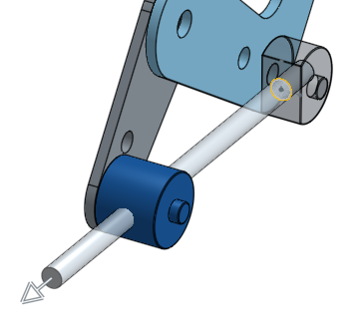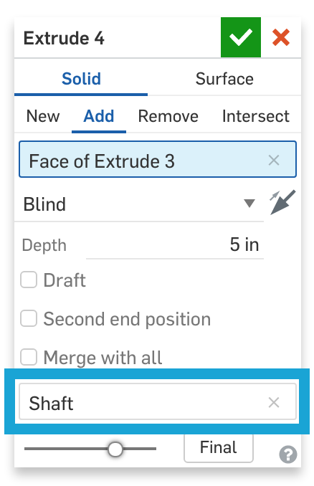

1. Next, extrude a 0.5” OD circle along the shaft, back towards the end hinge (Note the direction of the arrow in the picture). Note that the merge scope is once again the Shaft part.

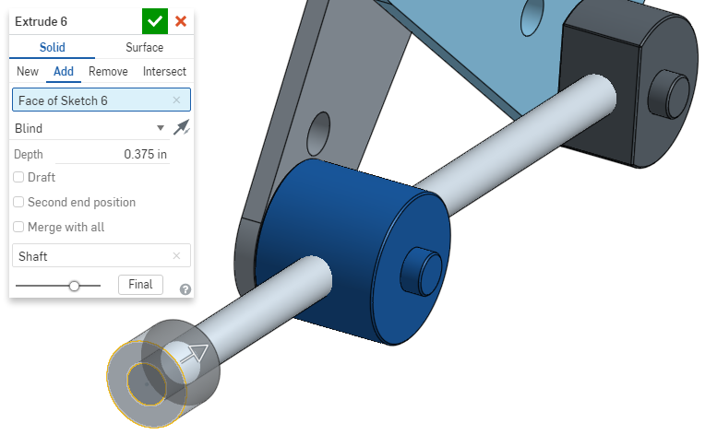

1. Next, let’s subtract the shaft from both hinges using a Boolean “Subtract” operation:

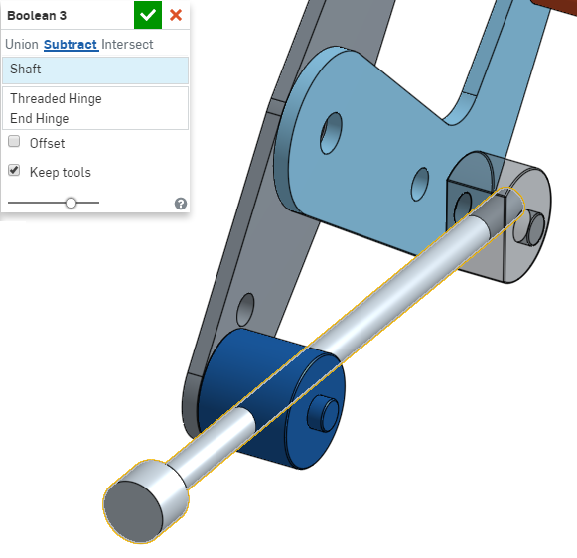

1. Next, let’s create a sketch on the Mid Plane, that we will use to extrude out a handle for our shaft. To expedite the sketching process, use the Use Tool  and click on the end of the shaft you just extruded. This will automatically create the two shorter edges of the dotted rectangle in the sketch below (Note the fully dimensioned sketch, and the use of construction lines)...

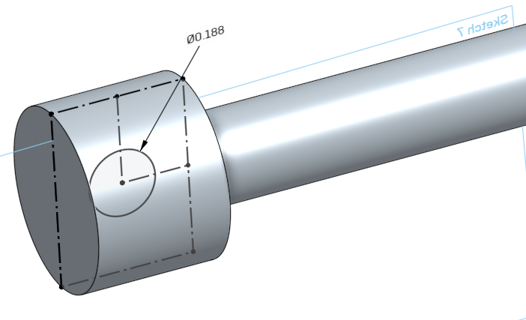

1. … and then extrude out the handle 1.5”. Create a new part, and call it “Handle”:

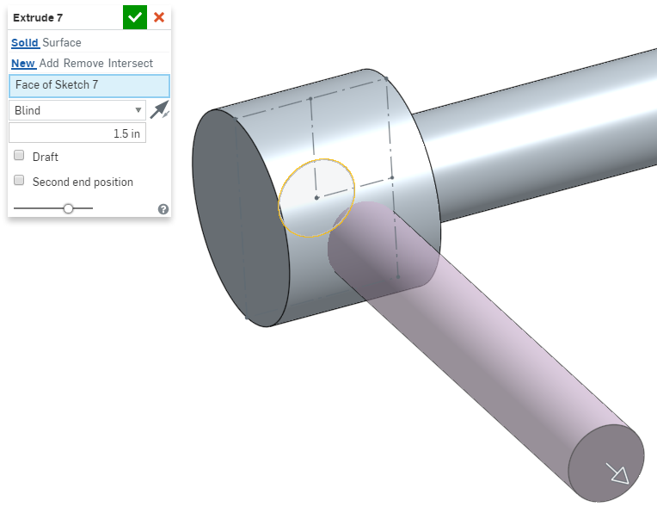

1. Next, sketch and extrude the end of the handle. Pay close attention to the direction of the extrude:

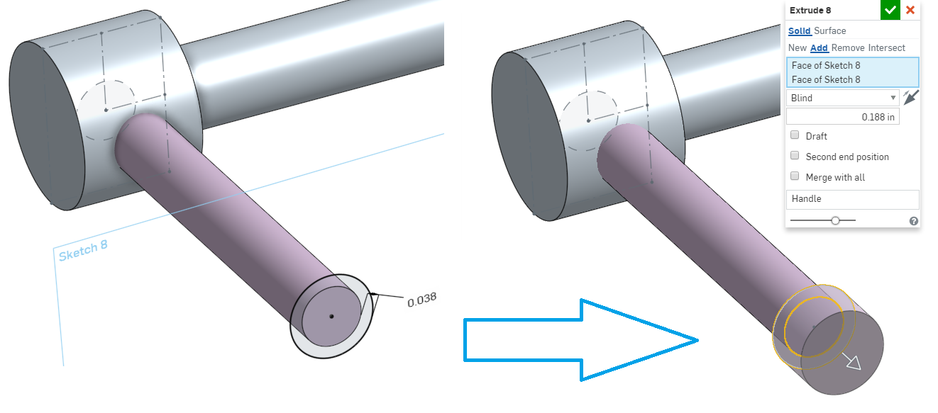

1. Next let’s add 2 fillet features, both of them with .05” radius:

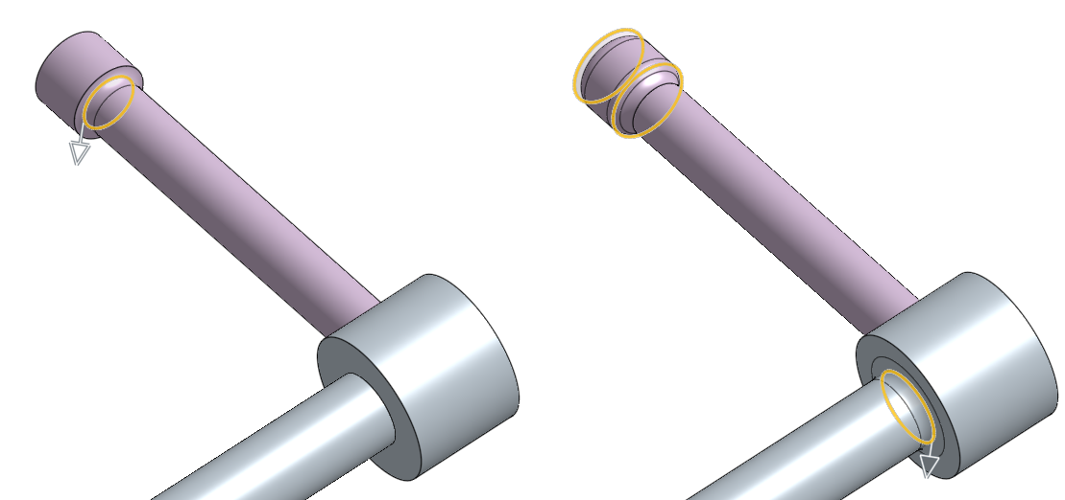

*Pro Tip: Try adding all of these fillets in a single feature. What happens? Why won’t it work? Are there workarounds, if so what? Discuss with your classmates the tradeoff of time spent vs. number of features. (Answer: In this case, adding two fillets is quicker & easier than creating the same geometry with a single revolve feature)*

1. Just like with the pins, let’s mirror the handle across the Mid Plane, and union it together.

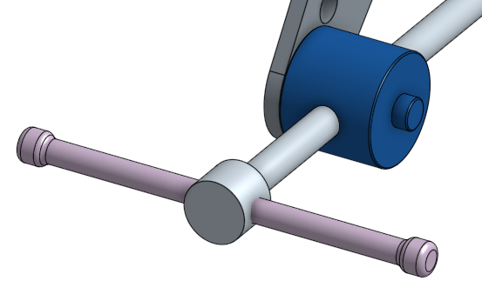

1. Use a Boolean “subtract” to fix the interference between the handle and the shaft. Which part is the tool, and which part is the target?

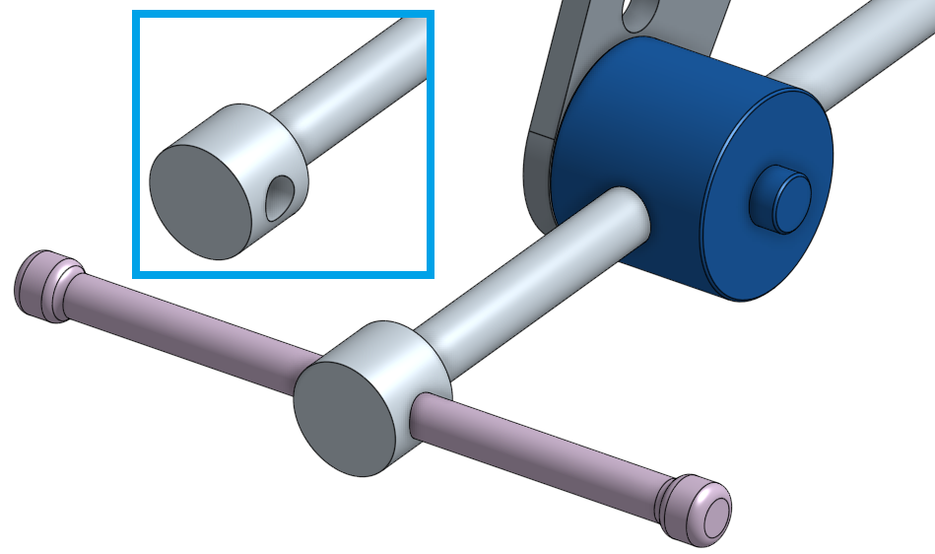

1. Let’s add a .005” chamfer (break edge) to the hole in the shaft:

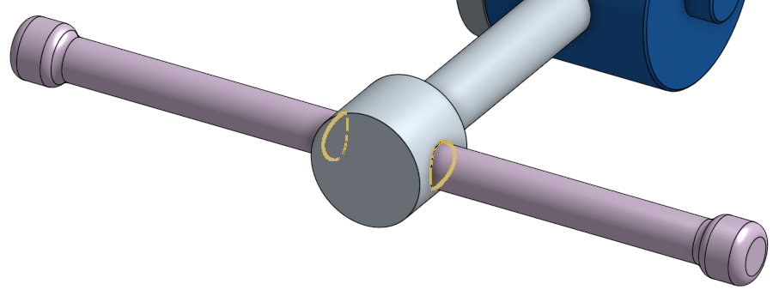

1. Add a .010” radius (another way to model a “break edge”) along the edges of both arms and the shaft:

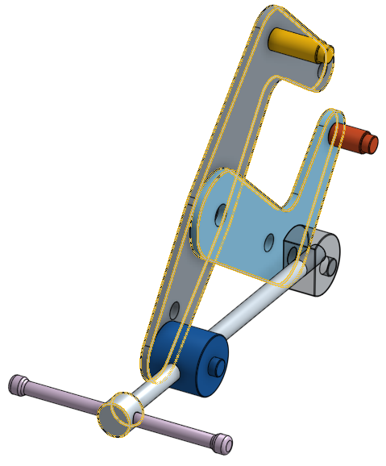

1. Now, let’s extrude the grips. Using sufficient constraints and design intent, create two new sketches on the planes of the arms, and extrude them up to the Mid Plane. Name the new upper part “Large Grip”, and the lower part “Small Grip” (A Side view is shown on the far right):

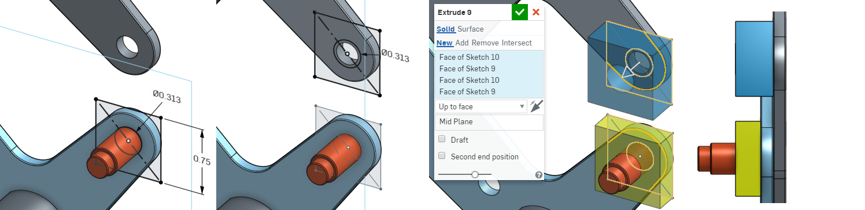

*Pro Tip: Note how the upper sketch does not have a dimension for the size of the square. So, how is it fully constrained? In this case, one of the edges of the square is constrained to be the same length as one of the edges of the square in the lower sketch! This is a high level of design intent, and is a very common practice amongst professional designers and engineers. It allows you to change the size of one square and have the other square update automatically.*

1. Next, we’re going to create a new plane to sketch on. Create a plane using the “Plane Point” method. This creates a plane through a selected point, and parallel to a selected plane. In this case, the point is the center of the lower grip sketch (the sketch may need to be unhidden to be selected) and the right side face of the upper grip sketch. Is this the only way to create a plane here? What other combinations of points and planes could be used?

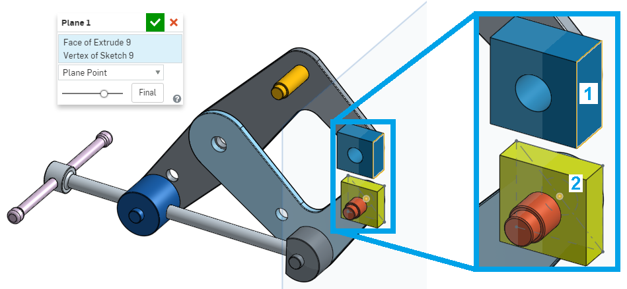

1. On this new plane, create the following sketch, using proper constraints and design intent. (All parts except for the grips have been hidden for clarity):

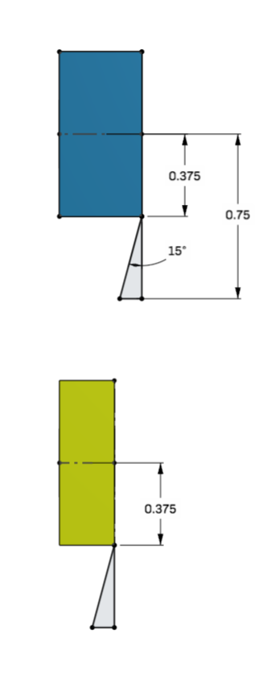

1. Now, we will create a revolve feature on the top Grip. Using our most recent sketch, revolve the triangular sketch region around the upper most centerline, and remove it from the Large Grip part:

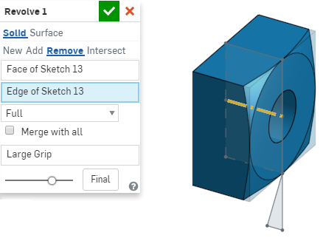

1. Repeat this process for the Small Grip:

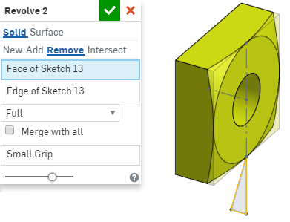

1. Now, just like with the pins and hinges, let’s mirror and union both grips across the Mid Pane:

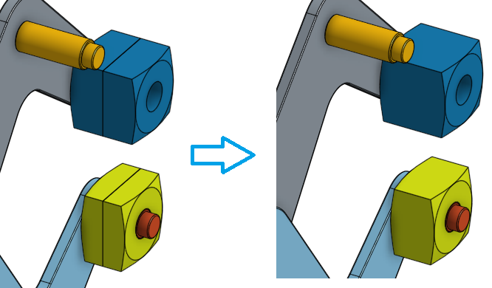

*Pro Tip: Note how we used the revolve feature to create a relief on the grip parts, then mirrored it over. In real life, this shape would be created (quite easily) on a lathe. In CAD, however, it actually took several steps: Creating the plane to sketch the profile, sketching the profiles, then revolving each profile. The profiles themselves aren’t that simple as they contain a significant amount of sketch entities and constraints. If we had not taken advantage of the symmetry, our revolve sketch profiles would have been twice as complicated.*

1. For our last pair of features, sketch and extrude two triangular reliefs in the grips. The profile of the top relief is a right isosceles triangle, as shown below, and the bottom profile is the same:

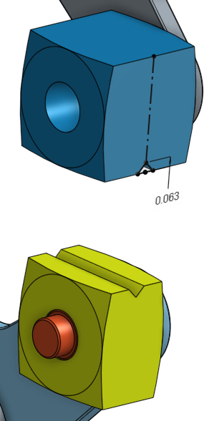

1. This model is now complete! It may not look complete yet, but recognize that all of the necessary parts and design intent are now built into this model. Right now, it is a just a nothing moves because all of our parts are in a Part Studio, but in the next lesson, we will insert the parts into an Assembly, add Mates, and make it move! Here is a screenshot of the completed model, and parts list:

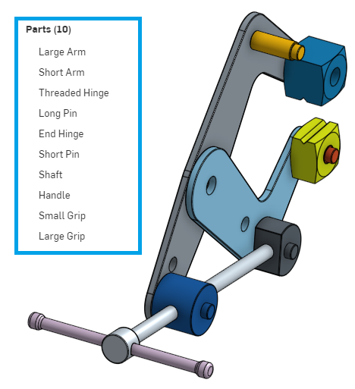

# Summary

Let’s take a second to reflect what we learned in this lesson.

1. We learned about the three Boolean operations - Union, Subtract, and Intersect.
2. We learned about linear and circular part patterning.
3. We were introduced to sketch patterning, which patterns sketch entities, not parts.
4. We learned about multi-part design in a single Part Studio.
5. We learned to use the Mirror tool to complete our “half model”.

Next week, we’ll continue with our Cantilever Clamp and create a moveable assembly, where we’ll be able to see the Clamp in action!